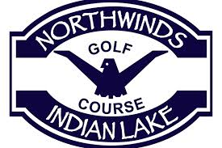

2017 CLUB CHAMPIONSHIP
SATURDAY AUGUST 12
8:00 AM
SENIOR FLIGHT
LADIES FLIGHT
CHAMPIONSHIP FLIGHT
NET FLIGHT

OPEN TO ALL MEMBERS OF NORTHWINDS AND NIGHTLY LEAGUE MEMBERS
Entry fee $25 plus green and/or cart fee
SIGN UP IN PRO SHOP OR CALL 754-GOLF

